**BUAN 6320 Database Foundations for Business Analytics**

**Assignment 9**

**Submitted BY: Abhishek Arya (**

**NET ID: axa220149)**

Ans 1

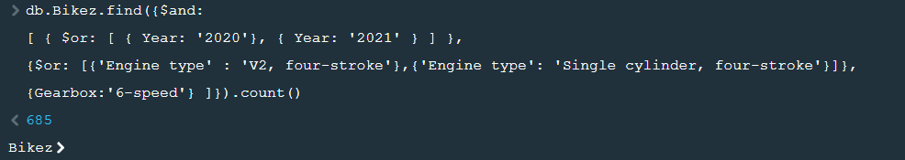

Ans2



Ans3

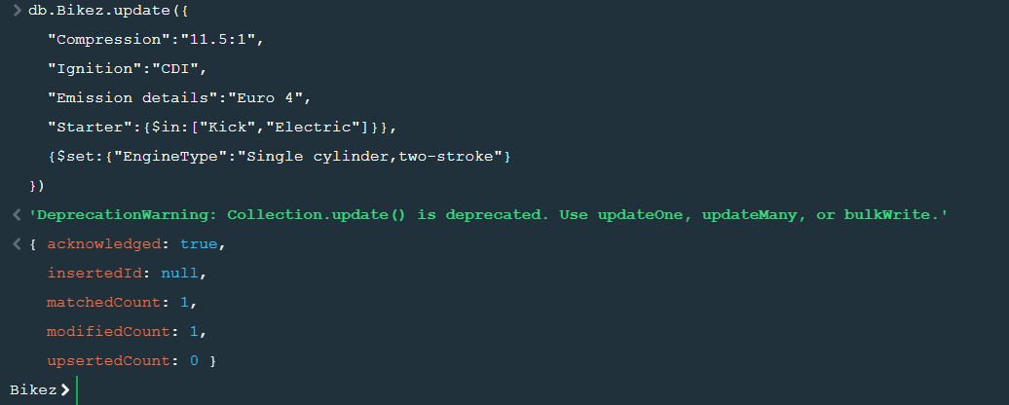

Ans4

